Unit Four: Puberty, Menstruation, Menopause and Andropause

**TOPIC 1: PUBERTY**

 Period when the endocrine and gametogenic functions of the gonads have first developed to the point where reproduction is possible

This is characterized by sequence of events by which a child becomes a young adult:

The beginning of gametogenesis

Secretion of gonadal hormones

Development of secondary sexual characters and reproductive functions

Sexual dimorphism is accentuated.

**Factors affecting the onset of puberty**

The age of onset of puberty varies and is more closely correlated with osseous maturation than with chronological age

Genetic/Ethnic factors

Environmental/Geographical factors

**Prepubertal stage (8–9 yr of age)**

The hypothalamic-anterior pituitary-gonadal axis is suppressed by;

Neuronal restraint pathways

Negative feedback provided by minute amounts of circulating gonadal steroids

Thus there are **undetectable serum levels of;**

luteinizing hormone (LH)

sex hormones (i.e., estradiol in girls, testosterone in boys)

**PREPUBERTY STAGE**

Evidence of hypothalamic-anterior pituitary-gonadal interaction during the prepubertal period resides in the fact that serum **follicle-stimulating hormone (FSH) concentrations are detectable in most children and may be increased (with serum LH concentrations) in;**

Turner syndrome

Anorchia

**Peripubertal period (1-3 yr before the onset of puberty)**

Pulsatile secretion of low levels of LH during sleep secondary to endogenous episodic discharge of hypothalamic gonadotropin-releasing hormone (GnRH).

Nocturnal pulses of LH continue to increase in amplitude and, to a lesser extent, in frequency as clinical puberty approaches.

Serum LH concentrations rise earlier in the course of the pubertal process in boys than in girls.

This pulsatile secretion of gonadotropins is responsible for;

Enlargement and maturation of the gonads

The secretion of sex hormones

Appearance of the secondary sex characteristics

NB

**GnRH is the major, if not the only, hormone responsible for the onset and progression of puberty.**

A second critical event occurs in middle or late adolescence in girls, in whom cyclicity and ovulation occur.

 A positive-feedback mechanism develops whereby rising levels of estrogen in midcycle cause a distinct increase of LH.

**Puberty in Girls (8-13yr)**

**Thelarche** (Development of Breasts) - Breast bud - 10–11 yrs

**Pubarche** (Development of axillary and pubic hair) - Appearance of pubic hair - 6–12 mo later

Peak height velocity occurs early (at breast stage II–III, typically between 11 and 12 yr of age) in girls and always precedes menarche.

**Menarche** (first menstrual period) Interval to menarche - 2–2.5 yr but may be as long as 6 yr after thelarche.

Mean age of menarche - 12.75 yr. (13.5 yrs in rural girls)

**Puberty in Boys (9-14yr)**

Growth of the testes (>3 mL in volume or 2.5 cm in longest diameter)

Thinning of the scrotum

Pigmentation of the scrotum

Growth of the penis, seminal vesicles and prostrate

Pubic hair then appears

Appearance of axillary hair usually occurs in midpuberty, 2 yr after pubic hair.

In boys, unlike girls, acceleration of growth (5-15cm/yr in early adolescence but later drops) begins after puberty is well under way and is maximal at genital stage IV–V (typically between 13 and 14 yr of age).

In boys, the growth spurt occurs approximately 2 yr later than in girls, and growth may continue beyond 18 yr of age.

**Adrenarche**

Adrenal cortical androgens also play a role in pubertal maturation.

Serum levels of **dehydroepiandrosterone (DHEA) and its sulfate (DHEAS) begin to rise at approximately 6–8 yr of age, before any increase in LH or sex hormones and before the earliest physical changes of puberty are apparent.**

NB

DHEAS is the most abundant adrenal C-19 steroid in the blood, and its serum concentration remains fairly stable over 24 hr; **a single measurement of this hormone is commonly used as a marker of adrenal androgen secretion.**

Although adrenarche typically antedates the onset of gonadal activity (i.e., gonadarche) by a few years, the two processes do not seem to be causally related, because adrenarche and gonadarche are dissociated in conditions such as;

Central precocious puberty

Adrenocortical failure

**ENDOCRINOLOGY IN PUBERTY**

The levels of gonadal steroids and gonadotropins are low until the age of 6–8 yrs

This is mainly due to the negative feedback effect of estrogen to the hypothalamic pituitary system (Gonadostat).

The gonadostat remains very sensitive (6–15 times) to the negative feedback effect, even though the level of estradiol is very low (10 pg/ml) during that time.

As puberty approaches this negative feedback effect of estrogen is gradually lost.

This results in some significant changes in the endocrine function of the girl.

**Hypothalamopituitary gonadal axis**

The GnRH pulses from hypothalamus results in pulsatile gonadotropin secretion (first during the night then by the day time).

GnRH → FSH, LH → Estradiol

The tonic and episodic secretion of gonadotropins in prepubertal period is gradually changed to one of cyclic release in postpubertal period

..

**Adrenal glands (Adrenarche)**

increase their activity of sex steroid synthesis (androstenedione, DHA, DHAS) from about 7 years of age.

Increased sebum formation, pubic and axillary hair and change in voice are primarily due to adrenal androgen production**.**

**Gonadarche:**

Increased amplitude and frequency of GnRH → ↑ secretion of FSH and LH → ovarian follicular development → ↑ estrogen.

Gonadal estrogen is responsible for the development of uterus, vagina, vulva and also the breasts

**Menarche**

The onset of first menstruation in life is called menarche.

It may occur anywhere between 10 and 16 years, the peak time being 13 years**.**

The first period is usually anovular.

The ovulation may be irregular for a variable period following menarche and may take about 2 years for regular ovulation to occur.

The menses may be irregular to start with.

**ADOLESCENCE**

The period of life beginning with puberty and ending with completed growth and physical maturity.

Between the ages of **10 - 19 yr (WHO), children undergo rapid changes in;**

Phenotypic changes: - Body size & Body shape

Neuroendocrine changes - Hormones set the developmental agenda in conjunction with social structures designed to foster the transition from childhood to adulthood.

Physiology

Psychological functioning

Social functioning

NB: 10-24 yr - Young Adults

**Marshall - Tanner Classification of Sex Maturity Stages in Girls**

**(Tanner JM, Growth of Adolescence, 1962)**

**SMR = sexual maturity rating.**

|  |  |  |
| --- | --- | --- |
| SMR Stage | Pubic Hair | Breasts |
| 1 | Preadolescent | Preadolescent |
| 2 | Sparse, lightly pigmented, straight, medial border of labia | Breast and papilla elevated as small mound; areolar diameter increased |
| 3 | Darker, beginning to curl, increased amount | Breast and areola enlarged, no contour separation |
| 4 | Coarse, curly, abundant but amount less than in adult | Areola and papilla form secondary mound |
| 5 | Adult feminine triangle, spread to medial surface of thighs | Mature; nipple projects, areola part of general breast contour |

**Marshall - Tanner Classification of Sex Maturity Stages in Boys**

|  |  |  |  |
| --- | --- | --- | --- |
| SMR Stage | PUBIC HAIR | PENIS | TESTES |
| 1 | None | Preadolescent | Preadolescent |
| 2 | Scanty, long, slightly pigmented | Slight enlargement | Enlarged scrotum, pink texture altered |
| 3 | Darker, starts to curl, small amount | Longer | Larger |
| 4 | Resembles adult type, but less in quantity; coarse, curly | Larger; glans and breadth increase in size | Larger, scrotum dark |
| 5 | Adult distribution, spread to medial surface of thighs | increase in size  Adult size | Adult size |

**Adolescence**

Developmental lines occur within three periods of adolescence;

**Early Adolescence – 10 – 13YRS**

**Middle Adolescence – 14-16yrs**

**Late Adolescence – 17-20 yrs and beyond**

|  |  |  |  |
| --- | --- | --- | --- |
| Variable | Early Adolescence | Middle Adolescence | Late Adolescence |
| Age (yr) | 10–13 | 14–16 | 17–20 and beyond |
| SMR* | 1–2 | 3–5 | 5 |
| Somatic | Secondary sex characteristics; beginning of rapid growth; awkward | Height growth peaks; body shape and composition change; acne and odor; menarche; spermarche | Slower growth |
| Sexual | Sexual interest usually exceeds sexual activity | Sexual drive surges; experimentation; questions of sexual orientation | Consolidation of sexual identity |
| Cognitive and moral | Concrete operations; conventional morality | Emergence of abstract thought; questioning mores; self–centered | Idealism; absolutism |
| Self–concept | Preoccupation with changing body; self–conscious | Concern with attractiveness, increasing introspection | Relatively stable body image |
| Family | Bids for increased independence; ambivalence | Continued struggle for acceptance of greater autonomy | Practical independence; family remains secure base |
| Peers | Same–sex groups; conformity; cliques | Dating; peer groups less important | Intimacy; possibly commitment |
| Relationship to society | Middle–school adjustment | Gauging skills and opportunities | Career decisions (e.g., dropout, college, work) |

Common Disorders of Puberty

•           Precocious puberty

•           Delayed puberty

•           Menstrual abnormalities (amenorrhea, menorrhagia, dysmenorrhea)

•          Others (infection, neoplasm, hirsutism, etc.)

**PRECOCIOUS PUBERTY**

The term precocious puberty is reserved for girls who exhibit any secondary sex characteristics before the age of 8 or menstruate before the age of 10.

Precocious puberty may be isosexual where the features are due to excess production of estrogen.

It may be heterosexual where features are due to excess production of androgen (from ovarian and adrenal neoplasm).

**FORMS OF PRECOCIOUS PUBERTY**

**GnRH dependent—80% (complete, central, isosexual or true)**

Constitutional—most common

Juvenile primary hypothyroidism

Intracranial lesions—trauma, tumor or infection

**Incomplete**

Premature thelarche

Premature puberche

Premature menarche

**CAUSES OF PRECOCIOUS PUBERTY**

**GnRH independent (precocious pseudopuberty or peripheral)**(Excess estrogen or androgen)

**Ovary**

Granulosa cell tumor

Theca cell tumor

Leydig cell tumor

Chorionic epithelioma

Androblastoma

McCune-Albright syndrome

**Adrenal**

Hyperplasia

Tumor

**Liver**

Hepatoblastoma

**Iatrogenic**

Estrogen or androgen intake

Precocious puberty in a girl aged  
2 years and 3 months

**DIAGNOSIS**

History

Basic investigations

X-ray, ct scan, MRI

Serum hCG, FSH, LH

Thyroid profile (TSH, T4)

Serum estradiol, testosterone, 17 OH progesterone, dehydroepiandrosterone (DHEA).

Electroencephalogram.

TREATMENT

**The goals are:**

 To reduce gonadotropin secretions.

 To suppress gonadal steroidogenesis or counteract the peripheral action of sex steroids.

 To decrease the growth rate to normal and slowing the skeletal maturation.

 To protect the girl from sex abuse.

DRUG MNX

**GnRH agonist therapy arrests the pubertal**precocity and growth velocity significantly.

The agonists suppress the premature activation of hypothalamopituitary axis due to down regulation and thereby diminished estrogen secretion.

**GnRH agonist therapy is the drug of choice in cases with GnRH dependent precocious puberty.**

GnRH agonist therapy suppresses FSH, lH secretion, reverses the ovarian cycle, establishes amenorrhea, causes regression of breast, pubic hair changes, and other secondary sexual characteristics.

This drug should be continued till the median age of puberty

**GnRH agonist**

•           Buserelin nasal spray 100 mg daily. It can slow down the process of skeletal maturation

•           **Medroxyprogesterone acetate—30 mg daily**orally or 100–200 mg. IM weekly to suppress gonadal steroids. It can suppress menstruation and breast development but cannot change the skeletal growth rate.

•           **Cyproterone acetate—It acts as a potent**progestogen, having agonist effects on progesterone receptors.

**Dose—70–100 mg/m2/day orally for 10 days starting**from 5th day of cycle.

**4. Danazol—It produces amenorrhea and arrest**breast development. But there is no effect on growth rate or skeletal maturation.

**2. DELAYED PUBERTY**

**Puberty is said to be delayed when the breast tissue and/or pubic hair have not appeared by 13–14 years or menarche appears as late as 16 years.**

The normal upper age limit of menarche is 15 years.

**CAUSES OF DELAYED PUBERTY**

•           Hypergonadotropic hypogonadism

Gonadal dysgenesis, 45 XO

Pure gonadal dysgenesis 46 XX, 46 XY

Ovarian failure 46 XX

2. Hypogonadotropic hypogonadism

Constitutional delay

Chronic illness, malnutrition

Primary hypothyroidism

Isolated gonadotropin defi ciency (Kallmann’s syndrome)

Intracranial lesions—tumors: craniopharyngioma, pituitary adenomas

3. Eugonadism

Anatomical causes

Müllerian agenesis

Imperforate hymen

Transverse vaginal septum

Androgen insensitivity syndrome

 Menstrual cycle

A periodic physiologic vaginal hemorrhage, occurring at approximately **28 ± 7 days interval (from the start of one menstrual period to the start of the next), and having its source from the shedding of uterine mucous membrane (menstruation); usually the bleeding is preceded by ovulation and predecidual changes in the endometrium.**

This may be teleologically regarded as periodic preparations for **fertilization and pregnancy.**

Menstruation is the visible manifestation of cyclic physiologic uterine bleeding due to shedding of the endometrium following invisible interplay of hormones mainly through hypothalamo-pituitaryovarian axis.

**For the menstruation to occur, the**axis must be actively coordinated, endometrium must be responsive to the ovarian hormones (estrogen and progesterone) and the outflow tract must be patent.

The first menstruation (**menarche**) occurs between 11–15 years with a mean of 13 years. It is more closely related to bone age than to chronological age

For the past couple of decades, the age of menarche is gradually declining with improvement of nutrition and environmental condition.

Physiologically, it is kept in abeyance due to pregnancy and lactation

Women have around **400 menstrual cycles**during the course of their lifetimes

Ultimately, it ceases between the ages 45–50 when **menopause** sets in

The duration of menstruation (menses) is about 4–5 days and the amount of blood loss is estimated to be 20 to 80mL with an average of 35mL.

Nearly 70% of total menstrual blood loss occurs in the first 2 days.

The menstrual discharge consists mainly of:

 dark altered blood,

mucus,

vaginal epithelial cells,

fragments of endometrium,

prostaglandins,

enzymes and bacteria.

**Prenatal follicular development**

During intrauterine fetal development, the ovary develops through **3 stages;**

**Genital ridge stage -**Sex cells can first be identified and begin as hypertrophy of the coelomic epithelium (future peritoneum) overlying the developing mesonephroi. Further growth of the ridges is dependent upon the arrival of germ cells.

**Indifferent stage -**Proliferation of germinal cells by mitosis and somatic cells

**Sexual differentiation stage -**Fundamental histologic differences between the ovary and testis are established

To maintain species-specific chromosome complement;

* the male gametes go through meiosis after puberty and continues throughout life owing to persistence of mitotically active “stem cells”, (spermatogonia)
* the female gametes undergo meiosis during fetal life and all stem cells are eliminated during birth when meiosis is suspended in the middle of the first meiotic division to resume shortly before ovulation in response to LH surge

The normal human menstrual cycle can be divided into two segments:

* the **ovarian cycle**and
* the **uterine cycle**, based on the organ under examination

**The ovarian cycle**

**Def:**is the cyclic hormonal changes and other series of changes that occur in the ovary to mature the immature follicle and recruit the oocyte.

It may be further divided into:

**Follicular phase**extends from the beginning of menstruation (day 1) to the onset of ovulation. The average length of the human follicular phase ranges from 10 to 14 days, and variability in this length is responsible for most variations in total cycle length.

**Ovulation.**

***luteal phase****(post ovulstory phase) extends from ovulation to the beginning of menstruation.*Unlike the follicular phase this phase is **most predictable and constant**(14 days) in length

**Ovarian cycle**

**the ovarian cycle consists of:**

Follicular phase:

Recruitment of groups of follicles

Selection of dominant follicle and its maturation.

Ovulation

Luteal phase:

Corpus luteum formation

Demise of the corpus luteum.

**Recruitment of groups of follicles (Preantral phase)**

The cohort of the growing follicles undergoes a process of development and differentiation which takes about **85 days and spreads over 3 ovarian cycles.**

It is not clear as to how many and which of the primordial follicles amidst several thousands are recruited for a particular cycle.

It is presumed that about 20 antral follicles (about 5–10 per ovary) proceed to develop in each cycle.

..

The initial recruitment and growth of primordial follicles are not under the control of any hormone.

After a certain stage (2–5 mm in size), the growth and differentiation of primordial follicles are under the control of FSH.

**Unless the follicles are rescued by FSH at this stage, they undergo atresia.**

..

With FSH, the oocyte is now surrounded by an acellular barrier of glycoprotein produced by the follicular cells and is called **zona pellucida.**

The flattened outer single layer pregranulosa cells become cuboidal and multilayered—now called **granulosa cells**

…

Then, there is appearance of channels (gap junctions) between the granulosa cells and the oocyte.

Through these gap junctions nutrition to the oocyte is maintained.

There is noticeable beginning of differentiation of the theca interna layer of ovarian stroma surrounding the follicle.

The granulosa cells now acquire FSH receptors.

**Antrum formation**

Then, there is accelerated growth of all the components of the follicles of the prentral phase.

The granulosa cells grow faster than the theca cells.

There is production of follicular fluid which is primarily an **ultrafiltrate** of blood from the vessels within theca interna.

The fluidfilled space is formed amidst the granulosa cells.

The spaces coalesce to form an **antrum**

**Dominant Follicle**

**As early as day 5–7, one of the follicles**out of so many becomes dominant and undergoes further maturation.

It seems probable that the one with **highest antral concentration of estrogen and lowest androgen** and whose granulosa cells contain the **maximum receptors for FSH**, becomes the dominant follicle.

The rest of the follicles become atretic by day 8

Further growth of dominant follicle

There is marked enlargement of the granulosa cells.

The granulosa cells surround the ovum to form **cumulus oophorus**which infact anchors the ovum to the wall of the follicle.

The cells adjacent to the ovum are arranged radially and is called **corona radiata**.

At this stage, **FSH induces LH receptors on the granulosa cells of the dominant follicle.**

**LH receptor**induction is essential for the mid-cycle LH surge to induce ovulation, luteinization of the granulosa cells to form corpus luteum and secretion of progesterone (two cell, two gonadotropin therapy)

Mature **Graafian follicle**

**The fully mature Graafian follicle**just prior to ovulation measures about 20 mm, and is composed of the following structures from outside inward:

•                Theca externa.

•                Theca interna.

•                Membrana granulosa (limitans).

•                Granulosa cell layer.

•                Discus proligerus in which the ovum is incorporated with cells arranged radially (corona radiata).

•                Antrum containing vesicular fluid.

NB

it takes 3 months for the follicle to grow and mature to ovulation—2 months to reach an antral stage measuring 1 mm; 2 weeks to reach 5 mm and another 2 weeks to reach 20mm before ovulation.

Hormonal changes during follicular phase of ovarian cycle…

At the start of the menstrual cycle, FSH levels begin to rise as the pituitary is released from the negative feedback effects of progesterone, oestrogen and inhibin.

Rising FSH levels rescue a cohort of follicles from atresia, and initiate **steroidogenesis.**

Under influence of FSH, a cavity forms around the ovum **(antrum formation).**

**NB. On steroidogenesis**

The basis of hormonal activity in pre-antral to pre-ovulatory follicles is described as the**'two cell, two gonadotrophin' hypothesis.**

Steroidogenesis is compartmentalized in the two cell types within the follicle: **the theca and granulosa cells.**

The two cell, two gonadotrophin hypothesis states that these cells are responsive to the gonadotrophins **LH and FSH respectively**.

Within the theca cells, **LH stimulates**the **production of androgens**from cholesterol.

Within the granulosa cells, **FSH stimulates**the conversion of thecally derived androgens to oestrogens (**aromatization)**.

In addition to its effects on aromatization, FSH is also responsible for the proliferation of granulosa cells.

Androgen production within the follicle **regulate** the development of the pre-antral follicle.

**Low levels of androgens**enhance aromatization and therefore increase oestrogen production.

In contrast, **high androgen levels inhibit aromatization**and produce follicular atresia.

A delicate balance of FSH and LH is required for early follicular development.

**The ideal**situation for the initial stages of follicular development is **low LH levels and high FSH levels**, as seen in the early menstrual cycle.

If LH levels are too high, theca cells produce large amounts of androgens, causing follicular atresia.

The selection of the dominant follicle is the result of complex signalling between the ovary and the pituitary.

Such a follicle has the most efficient aromatase activity and the **highest** concentration of FSH-induced LH **receptors.**

The dominant follicle therefore produces the greatest amount of **oestradiol and inhibin**.

Inhibin further amplifies LH-induced androgen synthesis, which is used as a substrate for oestradiol synthesis.

These features mean that the largest follicle therefore requires the **lowest levels of FSH (and LH)**for continued development.

At the time of follicular selection, FSH levels are declining in response to the negative-feedback effects of oestrogen.

The dominant follicle is therefore the only follicle that is capable of continued development in the face of falling FSH levels.

in-vitro fertilization (IVF) & multiple pregnancy

During in-vitro fertilization (IVF), the production of many ovulatory follicles is desired to harvest many oocytes.

with the administration of exogenous gonadotrophins, many follicles continue to develop and are released at ovulation, with an ensuing multiple gestation rate of around 30%

**INHIBIN & ACTIVIN**

Granulosa cell inhibin enhances LH -induced androgen synthesis.

The production of inhibin is a further mechanism by which FSH levels are reduced below a threshold at vlhich only the dominant follicle can respond, ensuring atresia of the remaining follicles.

Activin augments pituitary FSH secretion and increases FSH binding to granulosa cells.

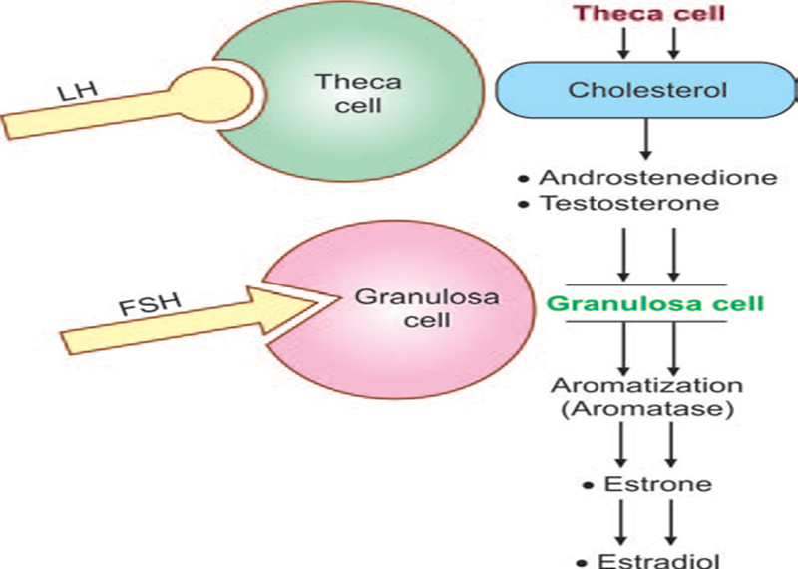

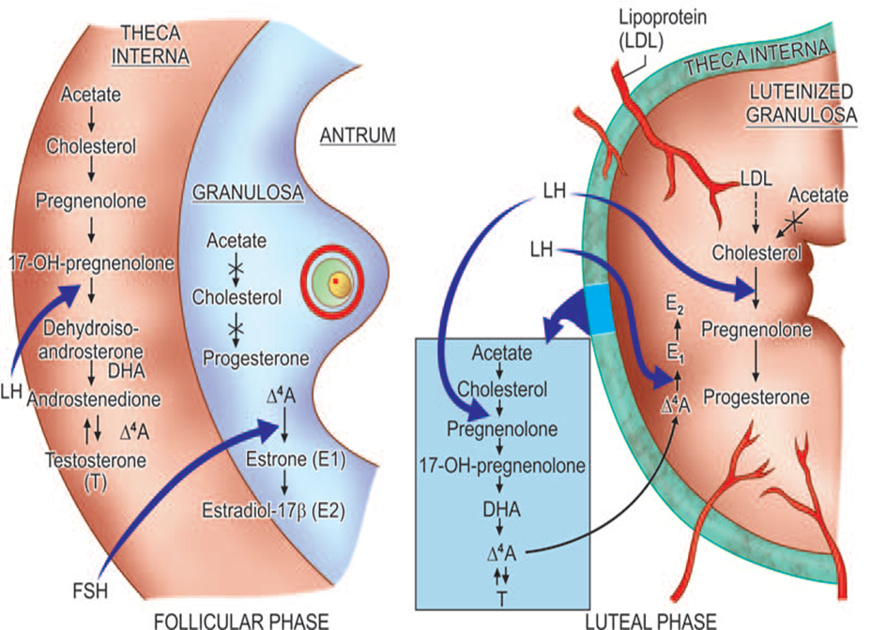

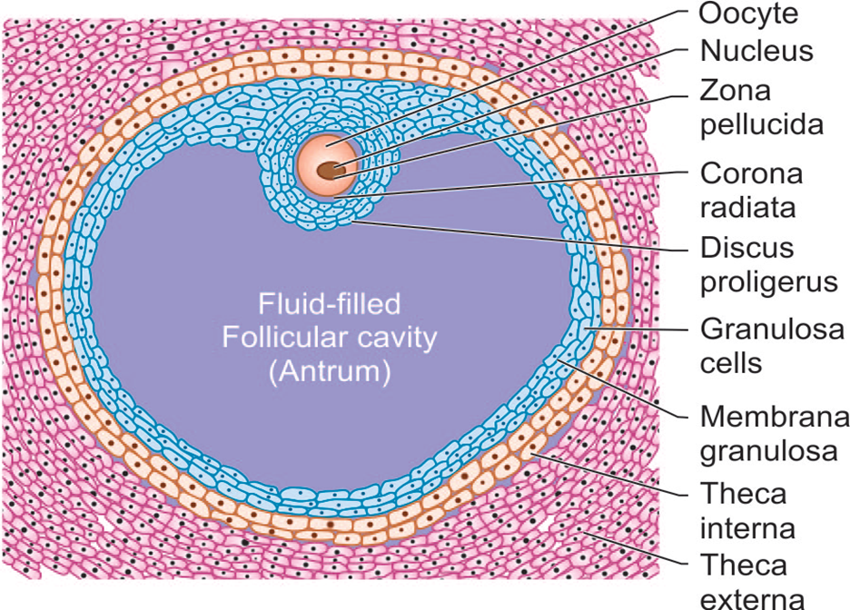

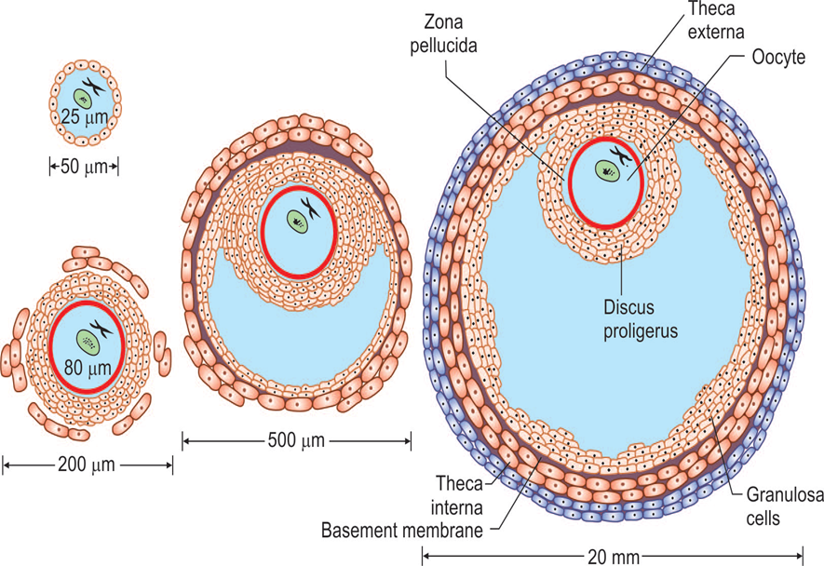

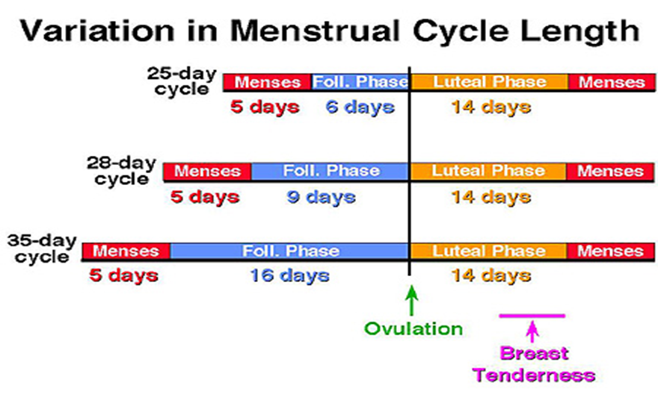

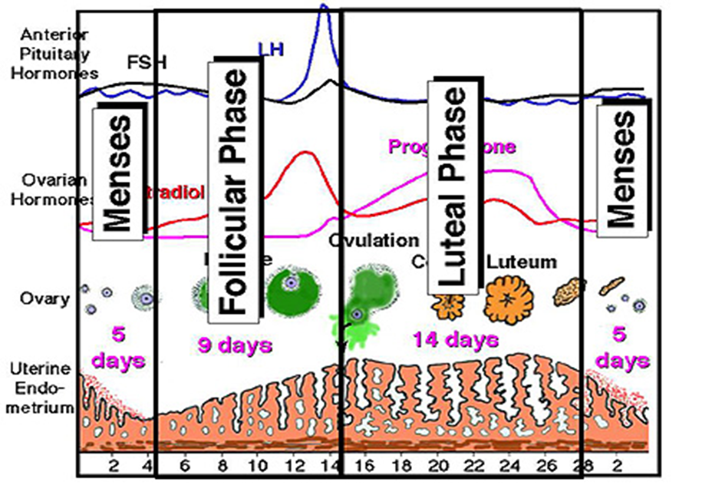

**Ovulation**

The dominant follicle, shortly before ovulation reaches the surface of the ovary.

The cumulus becomes detached from the wall, so that the **ovum with the surrounding cells (corona radiata)** floats freely in the liquor folliculi.

The oocyte completes the **first meiotic division**with extrusion of the first polar body which is pushed away.

The follicular wall near the ovarian surface becomes thinner.

**Hormonal changes at ovulation**

As the dominant follicle develops further, follicular **oestrogen production increases**.

Eventually the production of oestrogen is sufficient for it to reach the threshold required to exert a **positive-feedback** effect on pituitary **LH secretion**

LH levels increase, at first quite slowly (day 8 to day 12 of the menstrual cycle) and then more rapidly (day 12 onwards).

Hormonal changes at ovulation..

During this time, LH induces **luteinization** of granulosa cells in the dominant follicle, so that progesterone is produced.

Progesterone further amplifies the positive-feedback effect of oestrogen on pituitary LH secretion, leading to a surge of LH.

Ovulation occurs 36 hours after the onset of the LH surge.

**Hormonal changes at ovulation…**

In addition to the rise in LH, FSH and oestrogen that occurs around ovulation, a rise in serum androgen levels also occurs.

These **androgens** are derived from the stimulatory effect of LH on theca cells, particularly those of the non-dominant follicle.

This rise in androgens may have an important physiological effect in the **stimulation of libido**, ensuring that sexual activity is likely to occur at the time of ovulation, when the woman is at her most fertile and **enhance the process of atresia**of the small follicles.

**Hormonal changes at ovulation…**

Prior to the release of the oocyte at the time of ovulation, the LH surge stimulates the resumption of **meiosis**, a process which is completed after the sperm enters the egg (fertilization)

Hormonal changes at ovulation…

Additionally, the LH surge stimulates increased follicular leukocytes eg macrophage chemotactic protein-1 (MCP-I), interleukin 8 (IL-8) & neutrophils into the pre-ovulatory follicle.

Once activated, these leukocytes secrete mediators which cause the follicle wall to break down, releasing the oocyte at ovulation.

**LUTEAL PHASE**

Following ovulation, the follicle is changed to **corpus luteum**.

The ovum is picked up into the fallopian tube and undergoes either degeneration or further maturation, if fertilization occurs.

**Menstruation is unrelated to ovulation**and**anovular menstruation**is quite common during adolescence, following childbirth and in women approaching menopause.

**Corpus Luteum**

**Stage of Proliferation**

The opening through which the ovum escapes soon becomes plugged with fibrin.

The granulosa cells undergo hypertrophy without multiplication.

The cells become larger, polyhedral with pale vesicular nuclei and frothy cytoplasm.

The cells are called **granulosa lutein cells**.

The color of thecorpus luteum at this stage is **greyish yellow**due to presence of lipids

**Corpus luteum..**

**Stage of Vascularization**

Within 24 hours of rupture of the follicle, small capillaries grow into granulosa layer towards the lumen accompanied by lymphatics and fibroblasts.

Extensive vascularization within the corpus luteum ensures that the granulosa cells have a rich blood supply providing the precursors for steroidogenesis.

**Corpus luteum..**

**Stage of Maturation**

By 4th day, the luteal cells have attained the maximum size.

Approximately about 7–8 days following ovulation, the corpus luteum attains a size of about 1–2 cm and reaches its secretory peak.

The lutein cells become greatly enlarged and develop lipid inclusion, giving the cells a distinctive yellowish color. Cell contain a **yellow pigment**called **lutein**

**Corpus luteum**

**Stage of Regression**

On the day 22–23 of cycle, retrogression starts.

The first evidence of degeneration is appearance of vacuolation in the cells.

The lutein cells atrophy and the corpus luteum becomes **corpus albicans**.

Regression of corpus luteum is due to withdrawal of tonic LH support

If, however, fertilization occurs in the particular cycle, regression fails to occur, instead it is converted into **corpus luteum of pregnancy**.

**Hormonal changes in luteal phase**

is characterized by the production of progesterone from the corpus luteum within the ovary.

The production of progesterone from the corpus luteum is dependent on continued pituitary LH secretion.

However, serum levels of progesterone are such that LH and FSH production is relatively suppressed by inhibin.

The **low levels of gonadotrophins**mean that the initiation of **new follicular growth is inhibited**for the duration of the luteal phase.

**Hormonal changes in luteal phase**

In the absence of pregnancy and the production of human chorionic gonadotrophin (hCG) from the implanting embryo, the corpus luteum regresses at the end of the luteal phase, a process known as **luteolysis.**

As the corpus luteum dies, **oestrogen, progesterone and inhibin** levels decline.

The pituitary is released from the **negative-feedback** effects of these hormones, and gonadotrophins, particularly FSH, **start to rise**.

A cohort of follicles that happen to be at the pre-antral phase is rescued from atresia and a further menstrual cycle is initiated.

**Corpus Luteum of Pregnancy**

There is a surge of hyperplasia of all the layers between 23rd to 28th day due to chorionic gonadotropin.

**hCG, like LH will stimulate**the corpus luteum to secrete progesterone.

The growth reaches its peak at about 8th week when it measures about 2–3 cm.

Regression occurs following low levels of chorionic gonadotropin and the degenerative changes take place most frequently at about 6 months of gestation.

**Corpus luteum secretions**

predominantly progesterone is secreted by the corpus luteum to support the endometrium of the luteal phase.

There is also secretion of estrogen, inhibin and relaxin.

Progesterone along with estrogen from corpus luteum maintain the growth of the fertilized ovum.

This is essential till the luteal function is taken over by the placenta.

This turn over of function from corpus luteum of pregnancy to placenta is called **luteal-placental shift.**

**This transition period continues from seven weeks to ten weeks.**

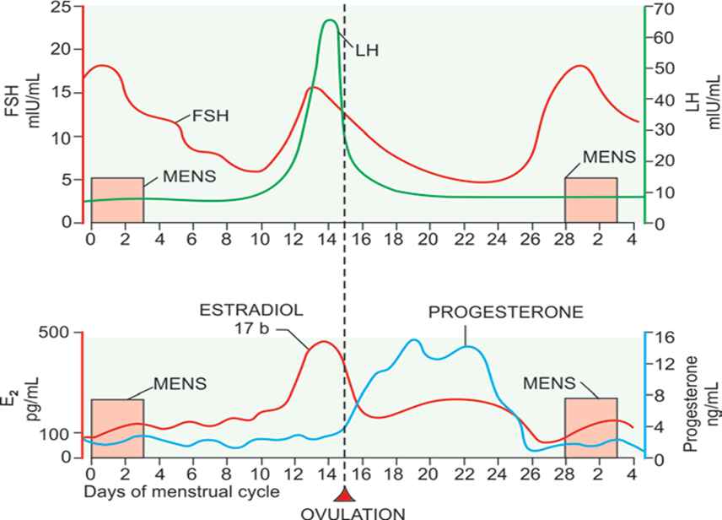

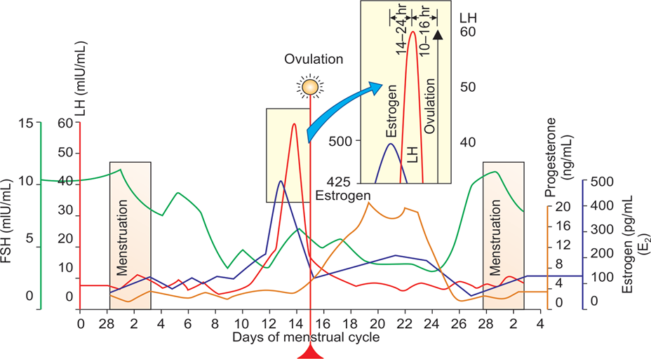

**UTERINE CYCLE**

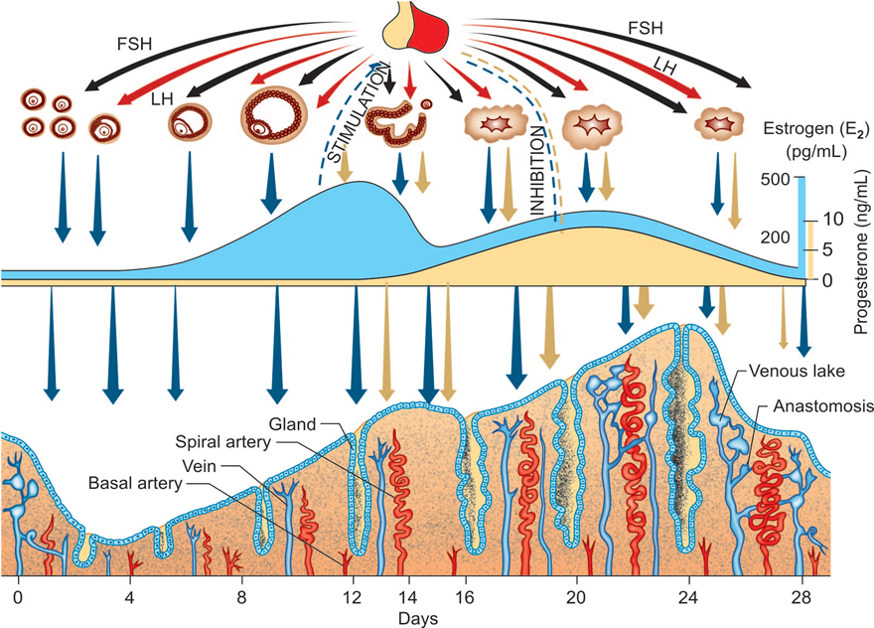

**ENDOMETRIUM**

The endometrium is the lining epithelium of the uterine cavity above the level of internal os.

It consists of **surface epithelium, glands, stroma and blood vessels.**

Two distinct divisions are established:**—**

**basal zone (stratum basalis) and**

**the superficial functional zone.**

**BASAL LAYER**

It is about one-third of the total depth of the endometrium and lies in contact with the myometrium.

The base of the endometrial glands extends into the layer.

The zone is uninfluenced by hormone and as such, no cyclic changes are observed.

 After shedding of the superficial part during menstruation, the regeneration of all the components occurs from this zone. **It measures about 1 mm.**

**FUNCTIONAL LAYER**

This zone is under the influence of fluctuating cyclic ovarian hormones, estrogen and progesterone.

The changes in different components during an ovulatory cycle has been traditionally divided into four stages:

Regenerative phase.

Proliferative phase.

Secretory phase.

Menstruation

**STAGE OF REGENERATION**

starts even before the menstruation ceases and is completed 2–3 days after the end of menstruation.

New blood vessels grow from the stumps of the old one.

The glands and the stromal cells are regenerated from the remnants left in the basal zone.

The glands are lined by the cubical epithelia.

**The thickness averages 2 mm.**

**STAGE OF PROLIFERATION**

extends from 5th or 6th day to 14th day (till ovulation).

The proliferative changes occurs due to rise in level of ovarian estrogens.

The glands become tubular and lie perpendicular to the surface.

The epithelium becomes columnar.

Unbranched spiral vessels with capillary congestion

**The thickness measures about 3–4 mm.**

**SECRETORY PHASE**

The changes of the components are due to the combined effects of estrogen and progesterone liberated from the corpus luteum after ovulation.

The endometrium contains receptors for progesterone which are induced by estrogen.

**Thus, the progesterone can only act on the endometrium previously primed by estrogen.**

It begins on day 15 and ceases 5–6 days prior to menstruation.

**The surface epithelium becomes more columnar**and ciliated at places.

The glands show predominant changes.

**The glands increase in size.**

**The lining**epithelium become taller.

There is appearance of vacuoles due to secretion of glycogen between the nuclei and the basement membrane.

**The glands become corkscrew-shaped. The blood vessels undergo marked spiraling.**

**The thickness of the endometrium reaches its highest (6–8 mm)**

The endometrial growth ceases 5–6 days prior to menstruation (22nd or 23rd day of cycle) in an infertile cycle.

The subepithelial capillaries and the spiral vessels are engorged.

**MENSTRUAL PHASE**

It is essentially degeneration and casting off an endometrium prepared for a pregnancy.

Regression of corpus luteum with fall in the level of estrogen and progesterone is an invariable preceding feature

Thes marked **spiralling** of the arteries and the **withdrawal of hormones estrogen and progesterone** causes intense spasm of the spiral arterioles at the basal part.

These two lead to **stasis and tissue anoxemia**.

There are evidences of infiltration of leucocytes and monocytes in the stroma.

Stasis of blood and spasm of the arterioles lead to damage of the arteriolar walls.

There is enzymatic autodigestion of the functional zone.

The bleeding occurs from the broken arteries, veins and capillaries and also from the stromal hematoma, with the superficial functional layer being shed into the uterine cavity

**The menstrual flow stops as a result of combined effect**of prolonged vasoconstriction, myometrial contraction and local aggregation of platelets with deposition of fibrin around them.

**ANOVULAR MENSTRUATION**

In an anovulatory cycle, the follicles grow without any selection of dominant follicle. The estrogen is secreted in increasing amount.

There may be imbalance between estrogen and FSH or because of temporary unresponsiveness of the hypothalamus to the rising estrogen, GnRH is suppressed → no ovulation.

The net effect is unopposed secretion of estrogen till the follicles exist.

The endometrium remains in either proliferative or at times hyperplastic state.

When the estrogen level falls, there is asynchronus shedding of the endometrium and menstruation.

The bleeding may be heavy or prolonged and irregular

This type of bleeding is mostly found during adolescence, following childbirth and abortion and in premenopausal period.

**ARTIFICIAL POSTPONEMENT**

The hormones used for deferment of the period are—combined oral pill, 2 tablets daily or progestogen such as norethisterone 5 mg twice daily.

The drug should be taken at least 3–6 days before the expected date of the period and continued until the crisis is over.

The period is expected 2–3 days after the drug is suspended.

**The normal menstrual cycle-clinical features**

normal menstrual cycle is 28 days +/- 7days

duration of menstrual flow is 3-7 days.

Menstrual cycles are longest immediately after puberty and in the 5 years leading up to the menopause, corresponding to the peak incidence of anovulatory cycles.

The length of the menstrual cycle is determined by the length of the follicular phase.

Once ovulation occurs, **luteal phase length is fairly fixed at 14 days** in almost all women.

Clinical features

The amount of menstrual flow peaks on the first or second day of menstruation.

The normal volume of menstrual loss is **35 mL**per month.

A menstrual loss of greater than **80 mL**is considered to be excessive - this level is rather arbitrary and corresponds to the threshold at which iron deficiency anaemia may ensue unless treated.

**New developments**

**IVF** - exogenous gonadotrophins are administered to stimulate follicular growth within the ovary

**GnRH antagonists**

**GnRH agonists**

**TOPIC 2: MENSTRUAL DISORDERS**

* Dysmenorrhea, mittelschmerz’s syndrome and Premenstrual syndrome

•           Abnormal uterine bleeding:

•           Amenorrhea and Oligomenorrhea

•           Polycystic ovarian syndrome

•           Dysfunctional uterine bleeding

•           Postmenopausal bleeding

**1. MITTELSCHMERZ’S SYNDROME (Ovular Pain)**

* Ovular pain is not an infrequent complaint.
* It appears  in the midmenstrual period.
* The pain is usually situated in the hypogastrium or in either iliac fossa.
* The exact cause is not known.

**The probable factors are:**

* •                  Increased tension of the Graafian follicle just prior to rupture,
* •                  Peritoneal irritation by the follicular fluid following ovulation and
* •                  Contraction of the tubes and uterus

**2. DYSMENORRHEA**

* Dysmenorrhea literally means painful menstruation.
* But a more realistic and practical definition includes cases of **painful menstruation of sufficient magnitude so as to incapacitate day-to-day activities.**
* **Prevalence:**Dysmenorrhea is a very common complaint, experienced by 45-95 per cent of women of reproductive age.

**Types:**

**Primary  
Secondary**

**PRIMARY DYSMENORRHEA (Spasmodic)**

* The primary dysmenorrhea is one where there is no identifiable pelvic pathology.
* The incidence of primary dysmenorrhea of sufficient magnitude with incapacitation is about 15–20%.
* The risk factors for primary dysmenorrhoea include:
* duration of menstrual flow of > 5 days,
* younger than normal age at menarche,
* cigarette smoking.
* There is some evidence to support the assertion that dysmenorrhoea improves after childbirth, and it also appears to decline with increasing age.
* The severity of pain usually lasts for few hours, may extend to 24 hours but seldom persists beyond 48 hours.

**SECONDARY DYSMENORRHEA  
(Congestive)**

* is normally considered to be menstruation — associated pain occurring in the presence of pelvic pathology.
* The pain may be related to increasing tension in the pelvic tissues due to pre-menstrual pelvic congestion or increased vascularity in the pelvic organs.

**Common causes of secondary dysmenorrhea:**

* chronic pelvic infection,
* Pelvic endometriosis,
* adenomyosis
* pelvic adhesions / Asherman's syndrome
* Uterine fibroid,
* endometrial polyp,
* IUCD *in utero*
* *Pelvic*congestion.
* (rarely) cervical stenosis.
* Obstruction due to mullerian malformations
* NB: some definitions
  + ***Endometriosis:***Endometrial stroma & glands remote of the uterine cavity, responsive to ovarian hormone variations with fibrosis of surrounding tissues
  + *Sites;*Uterine ligaments, bowel, urinary tract, pelvic peritonuem, ovaries, abdominal wall, perineum & vagina.
  + ***Adenomyosis/endometriosis interna:***Extension of endometrial glands and stroma into the myometrium

**Clinical features of secondary dysmenorhea**

* The pain is dull, situated in the back and in front without any radiation.
* It usually appears 3–5 days prior to the period and relieves with the start of bleeding.
* The onset and duration of pain depends on the pathology producing the pain.
* There is no systemic discomfort unlike primary dysmenorrhea.
* The patients may have got some discomfort even in between periods

**Treatment of dysmenorhea**

* NSAIDs, such as naproxen, ibuprofen and mefenamic acid, are reasonably effective. Aspirin,  Mefenamic acid (500mg TID)
* Oral contraceptives are widely used but, surprisingly, there is little evidence.
* Surgical treatments aimed at interrupting the nerve pathways from the uterus have been employed
* Treat underlying conditions
* Conservative mgt; taking a hot bath, using a hot water bottle and relaxing in bed

**3. PREMENSTRUAL SYNDROME (PMS) (Syn : Premenstrual Tension)**

* is the occurrence of cyclical psychoneuroendocrine disorder of unknown etiology, often noticed just prior to menstruation (in luteal phase-premenstrual) and resolve by the time menstruation ceases.
* Occur during the last 7–10 days of the menstrual cycle.

**It should fulfil the following criteria:**

* Not related to any organic lesion.
* cyclic symptoms occurring only during luteal phase
* Symptoms must be severe enough to disturb the lifestyle of the woman or she requires medical help.
* Symptom-free period during rest of the cycle.
* symptoms relieved with onset of menses
* symptoms present for at least 3 cycles

**Pathophysiology:**

The exact cause is not known but the **following hypotheses are postulated :**

(a) Alteration in the level of estrogen and progesterone starting from the midluteal phase. Either there is altered estrogen : progesterone ratio or diminished progesterone level.

(b) Neuroendocrine factors :

* **Serotonin is an important neurotransmitter in**the CNS. During the luteal phase, decreased synthesis of serotonin is observed in women suffering from PMS.
* **Endorphins: The symptom complex of PMS**is thought to be due to the withdrawal of endorphins (neurotransmitters) from CNS during the luteal phase.
* γ**-aminobutyric acid (GABA) suppresses the**anxiety level in the brain. Medications that are GABA agonist, are effective.

(c) Psychological and psychosocial factors may be involved to produce behavioral changes.

**Unfortunately, nothing is conclusive**

**CLINICAL FEATURES**

* Bloating
* cyclical weight gain
* Mastalgia
* abdominal cramps
* Fatigue
* Headache
* depression
* irritability.

**TREATMENT OF PMS**

* As the etiology is multifactorial and too often obscure, various drugs are used either on speculation or empirically with varying degrees of success.
* **Life style modification and congnitive behavior therapy are important steps.**
* **Nonpharmacological:**
  + **Assurance, Yoga,**Stress management, Diet manipulation.
  + Avoidance of salt, caffeine and alcohol specially in second half of cycle improves the symptoms.

**Nonhormonal :**

* + - Tranquilizers or antidepressant drugs, may be of help logically.
    - Pyridoxine 100 mg Bid  is helpful by correcting tryptophan metabolism - depression.
    - D**iuretics** - Frusemide 20 mg OD for consecutive 5 days a week reduces fluid retention.
    - **Anxiolytic**agents are found to be helpful to women having persistent anxiety. Alprazolam 0.25 mg, BID) is given during the luteal phase of the cycle.
    - **Selective Serotonin Reuptake Inhibitors (SSRI**) (eg Fluoxetine 20mg) **and Noradrenaline Reuptake Inhibitors (SNRI)**are found to be very effective.

**Hormones:**

* + **Oral contraceptive pills:**The idea is to suppress ovulation and to maintain an uniform hormonal milieu. The therapy is to be continued for 3–6 cycles.
  + **Progesterone is not effective in treating PMS.**
  + **Spironolactone:**It is a potassium sparing diuretic. It has anti-mineralocorticoid and anti-androgenic effects. It is given in the luteal phase (25–200 mg/day).
  + **Bromocriptine: 2.5 mg daily or twice daily**may be helpful, at least to relieve the breast complaints.
  + **Oophorectomy -**primary PMS with recurrence of symptoms and approaching to menopause, hysterectomy with bilateral oophorectomy is a last resort
  + **Suppression of ovarian cycle**
    - * Medical oopherectomy - GnRH agonist for 6 months
      * **Danazol 200 mg daily**is to be adjusted so as to produce amenorrhea

**ABNORMAL UTERINE BLEEDING**

**Any uterine bleeding outside the normal volume, duration, regularity or frequency is considered abnormalnuterine bleeding (AUB).**

Description of alteration in the normal pattern of menstrual flow

 Forms;

Excessive flow

Prolonged flow

Intermenstrual bleeding

Types;

          -         hypermenorrhoea                 -        metrorrhagia

          -         polymenorrhoea               -         amenorrhoea

          -         menometrorrhagia                -        menorrhagia

          -         oligomenorrhoea

**1. MENORRHAGIA  
(Syn : Hypermenorrhea)**

Menorrhagia is defined as cyclic bleeding at normal intervals; the bleeding is either excessive in amount (> 80 mL) or duration (>7 days) or both.

The term **menotaxis**is often used to denote prolonged bleeding.

**Classification of menorrhagia**

Menorrhagia can be classified as:

idiopathic, where no organic pathology can be found: also known as dysfunctional uterine bleeding-(DUB).

secondary to an organic cause, such as fibroids.

**Causes:**

**1. Organic:**

a**. Pelvic causes:**

* Fibroid uterus
* Adenomyosis
* Pelvic endometriosis
* IUCD inutero
* Chronic tubo-ovarian mass
* Tubercular endometritis (early cases)
* Retroverted uterus—due to congestion
* Granulosa cell tumor of the ovary

***b. Systemic:***

***Liver dysfunction—f****ailure to conjugate and*thereby inactivates the estrogens.

* Congestive cardiac failure.
*  Severe hypertension

***c. Endocrinal***

* Hypothyroidism.
* Hyperthyroidism.

***d. Hematological***

*  Idiopathic thrombocytopenic purpura.
*  Leukemia.  von Willebrand’s disease.
*  Platelet deficiency.

2. **Functional**

* Due to disturbed hypothalamo-pituitary-ovarianendometrial axis.

**COMMON CAUSES OF MENORRHAGIA**

* Dysfunctional uterine bleeding
* Fibroid uterus
* Adenomyosis
* Chronic tubo-ovarian mass

**Diagnosis & treatment**

* number of towels and tampons used per day is useful
* irregular, intermenstrual or postcoital bleeding, a sudden change in symptoms, dyspareunia, pelvic pain or premenstrual pain, and excessive bleeding from other sites or **in other situations (e.g. after tooth**extraction).
* Long duration of flow, passage of big clots, use of increased number of thick sanitary pads, pallor, and low level of hemoglobin give an idea about the correct diagnosis and magnitude of menorrhagia.

**Treatment**: The definitive treatment is appropriate to the cause for menorrhagia**.**

Some Definitive Treatment

*Drugs that are compatible with ongoing attempts at conception*

* Mefenamic acid and other non-steroidal, anti-inflammatory drugs (NSAIDs)
* Tranexamic acid
* *Drugs that are incompatible with ongoing attempts at conception but not licensed for use as contraceptives*
* Danazol
* *used as contraceptives that are effective in the treatment of menorrhagia*
* Combined oral contraceptive pill
* levonorgestrel intrauterine system.
* *Second-line drugs with few advantages over the forgoing, and whose side effects limit long-term use*
  + - * Danazol
      * Gestrinone
      * Gonadotrophin-releasing hormone analogues
      * Medical and surgical treatments that are ***not*effective**in the treatment of menorrhagia
      * Ethamsylate
      * Luteal phase progestogens
      * Uterine curettage

**Surgical treatments for menorrhagia**

* **ablation of the endometrial lining**of the uterus to sufficient depth prevents regeneration of the endometrium.
* ***Hysterectomy***

**2. POLYMENORRHEA (SYN : EPIMENORRHEA)**

* is defined as cyclic bleeding where the cycle is reduced to an arbitrary limit of less than 21 days and remains constant at that frequency.
* If the frequent cycle is associated with excessive and or prolonged bleeding, it is called **epimenorrhagia**.

**Causes & treatment**

**Dysfunctional:**

* It is seen predominantly during adolescence, preceding menopause and following delivery and abortion.
* Hyperstimulation of the ovary by the pituitary hormones may be the responsible factor.

**Ovarian hyperemia**as in PID or ovarian endometriosis.

**Treatment:**

**Persistent dysfunctional type is to be treated**by hormone as in DUB

**ABNORMAL UTERINE BLEEDING 2**

**3. METRORRHAGIA**

* is defined as irregular, acyclic bleeding from the uterus.
* Amount of bleeding is variable.
* While metrorrhagia strictly concerns uterine bleeding but in clinical practice, the bleeding from any part of the genital tract is included under the heading.
* Then again, irregular bleeding in the form of **contact bleeding or** **intermenstrual bleeding**in an otherwise normal cycle is also included in metrorrhagia.
* In fact, it is mostly related to surface lesion in the uterus.

**Menometrorrhagia**is the term applied when the bleeding is so irregular and excessive that the menses (periods) cannot be identified at all.

**CAUSES OF ACYCLIC BLEEDING**

* DUB—usually during adolescence, following childbirth and abortion and preceding menopause
* Submucous fibroid
* Uterine polyp
* Carcinoma cervix and endometrial carcinoma

**CAUSES OF CONTACT BLEEDING**

* Carcinoma cervix
* Mucos polyp of cervix
* Vascular ectopy of the cervix especially during pregnancy, pill use cervix
* Infections—chlamydial or tubercular cervicitis
* Cervical endometriosis

**CAUSES OF INTERMENSTRUAL BLEEDING**

* Apart from the causes of contact bleeding, other causes are:
*  Urethral caruncle 
* Ovular bleeding
*  Breakthrough bleeding in pill use
*  IUCD in utero 

**Treatment of metrorhagia**

Treatment is directed to the underlying pathology.

**Malignancy is to be excluded prior to any definitive treatment**ecubitus ulcer

**4. OLIGOMENORRHEA**

* **Definition: Menstrual bleeding occurring more than 35 days apart and which remains constant at**that frequency is called oligomenorrhea.

**COMMON CAUSES OF OLIGOMENORRHEA**

*  Age-related—during adolescence and preceeding menopause
* Weight-related—obesity
* Stress and exercise related
* Endocrine disorders—PCOS (commonest), hyperprolactinemia, hyperthyroidism
* Androgen producing tumors—ovarian, adrenal
* Tubercular endometritis—late cases
* **Drugs:**
* Phenothiazines
* Cimetidine
* Methyldopa

**ABNORMAL UTERINE BLEEDING 3**

**5. AMENORRHOEA**

* absence of menstruation.
* It may be classified as either primary or secondary.
* There are, physiological situations in which amenorrhoea is normal, namely:
* pregnancy,
* lactation and
* prior to the onset of puberty.

**Classification of amenorrhoea**

* Primary amenorrhoea: condition in which girls fail to develop secondary sexual characteristics by 14 years of age or fail to menstruate by 16 years of age.
* Secondary amenorrhoea: describes the cessation of menstruation for more than 6 months in a normal female of reproductive age that is not due to pregnancy.

**Causes of amenorrhoea**

* Reproductive outflow tract disorders
* Asherman 's syndrome
* Mullerian agenesis
* Transverse vaginal septum
* Imperforate hymen
* Testicular feminization syndrome
* Ovarian disorders
* Anovulation, e.g. polycystic ovarian synd rome (peaS)
* Gonadal dysgenesis, e.g. Turner's syndrome
* Premature ovarian failure
* Resistant ovary syndrome
* Pituitary disorders
* Adenomas such as prolactinoma
* Pituitary necrosis, e.g. Sheehan's syndrome
* Hypothalamic malfunctions
* Resulting from excessive exercise
* Resulting from weight loss/anorexia nervosa
* Resulting from stress
* Craniopharyngioma
* Kallman 's syndrome

**Diagnosis & treatment**

* Detailed history and examination
* Investigations
* *Initial hormone tests:*
  + Pregnancy test,
  + Prolactin,
  + Thyroid function,
  + LH and FSH,
  + Testosterone – androgen producing tumours
* Treat the cause.

**6. HYPOMENORRHEA**

**Definition:**When the menstrual bleeding is unduly scanty and lasts for less than 2 days, it is called hypomenorrhea.

**Causes**

* The causes may be:
* **local** (uterine synechiae or endometrial tuberculosis),
* **endocrinal** (use of oral contraceptives, thyroid dysfunction, and premenopausal period), or systemic (malnutrition).

**ABNORMAL UTERINE BLEEDING 4**

**7. DYSFUNCTIONAL UTERINE BLEEDING (DUB)**

* **DUB** is defined as a state of abnormal uterine bleeding without any clinically detectable organic, systemic, and iatrogenic cause (Pelvic pathology, e.g. tumor, inflammation or pregnancy is excluded).
* **NB: Heavy menstrual bleeding (HMB)**is defined as a bleeding that interferes with woman's physical, emotional, social and maternal quality of life.

DUB

* The bleeding may be abnormal in frequency, amount, or duration or combination of any three.
* As **the diagnosis is based with the exclusion of ‘organic lesion’,***Currently DUB is defined as a state of abnormal uterine bleeding following anovulation due to dysfunction of hypothalamo-pituitary-ovarian axis (endocrine origin).*

Pathophysiology

* The endometrial abnormalities may be *primary or secondary to****incoordination in the hypothalamopituitary-*ovarian axis.**
* It is thus *more prevalent in extremes of reproductive period—adolescence and*premenopause or following childbirth and abortion.
* The abnormal bleeding may be associated with or without ovulation and accordingly grouped into :
  + - * **Ovular bleeding**
      * **Anovular bleeding**

**OVULAR BLEEDING**

* **Polymenorrhea or polymenorrhagia:**
* usually occurs following childbirth and abortion, during adolescence and premenopausal period, and in pelvic inflammatory disease.
* The follicular development is speeded up with resulting shortening of the follicular phase.
* This is probably due to hyperstimulation of the follicular growth by FSH.
* Rarely, the luteal phase may be shortened due to premature lysis of the corpus luteum.
* Sometimes, it is related to stress induced stimulation.
* **Oligomenorrhea:**
* Primary ovular oligomenorrhea is rare.
* Common in adolescence and premenopause.
* The disturbance may be due to ovarian unresponsiveness to FSH or secondary to pituitary dysfunction.
* There is undue prolongation of the proliferative phase with normal secretory phase.

**ANOVULAR BLEEDING**

* **Menorrhagia**
* Anovular bleeding is usually excessive.
* In the absence of growth limiting progesterone due to anovulation, the endometrial growth is under the influence of estrogen throughout the cycle.
* There is inadequate structural stromal support and the endometrium remains fragile.
* Thus, with the withdrawal of estrogen due to negative feedback action of FSH, the endometrial shedding continues for a longer period in asynchronous sequences because of lack of compactness
* **Cystic glandular hyperplasia**
* This type of abnormal bleeding is usually met in premenopausal women
* There is slow increase in secretion of estrogen but no negative feedback inhibition of FSH.
* The net effect is gradual rise in the level of estrogen with concomittant phase of amenorrhea for about 6–8 weeks.
* As there is no ovulation, the endometrium is under the influence of estrogen without being opposed by growth limiting progesterone for a prolonged period.

**diagnosis**

* History, physical examination & Investigations aim at:
* To confirm the menstrual abnormality as stated by the patient.
* To exclude the systemic, iatrogenic, and ‘organic’ pelvic pathology.
* To identify the possible etiology of DUB.
* To work out the definite therapy protocol.

**MANAGEMENT**

* Because of diverse etiopathology of DUB in different phases of woman’s life, the management protocols have been grouped accordingly.
  +  Pubertal and adolescent menorrhagia < 20 years.
  +  Reproductive period (20–40 years).
  +  Premenopausal (> 40 years).
  +  Postmenopausal.

Management

**General**

* Rest is advised during bleeding phase.
* Assurance and sympathetic handling are helpful particularly in adolescents.
* Anemia should be corrected energetically by diet, hematinics, and even by blood transfusion.
* Clinically evident systemic or endocrinal abnormalities should be investigated and treated accordingly.

**MEDICAL**

* potent **orally active progestins, are the mainstay in the management of DUB in all age groups.**
* **Mechanism of antiestrogenic action of progestins are:**
  + •                It stimulates the enzyme (17-β-hydroxy steroid dehydrogenase) that converts estradiol to estrone (less potent).
  + •                Inhibits induction of estrogen receptor.
  + •                It has antimitotic effect on the endometrium.
* While isolated progestins therapy is highly effective in anovular DUB, in ovular DUB combined preparations of progestogen and estrogen (combined oral pills) are effective.
* **To stop bleeding and regulate the cycle :**Norethisterone preparations (5 mg tab) are used thrice daily till bleeding stops, which it usually does by 3–7 days.

**Cyclic Therapy:**

* *In ovular bleeding,***Any low dose combined oral pills** are effective when given 5th to 25th day of cycle for 3 consecutive cycles. It causes endometrial atrophy. It is more effective compared to progesterone therapy as it suppress the hypothalamopituitary axis more effectively. Normal menstruation is expected to resume with restoration of normally functionating pituitary–ovarian-endometrial axis
* *In anovular bleeding: Cyclic progestogen preparation*of medroxyprogesterone acetate (MPA) 10 mg or norethisterone 5 mg is used from 5th to 25th day of cycle for 3 cycles

**NON-HORMONAL MANAGEMENT**

* **Anti-fibrinolytic agents**- Tranexamic acid
* **Prostaglandin synthetase**inhibitors: eg Mefenamic acid 150-600mg is much effective in women aged more than 35 years and in cases of ovulatory DUB during bleeding phase.
* **Desmopressin: It is a synthetic analogue of**arginine-vasopressin. indicated in von Willebrand’s disease and factor VIII deficiency. It is given IV (0.3 μg/kg) or intranasally.

**SURGICAL MANAGEMENT OF DUB**

* Uterine curettage
* Endometrial ablation/resection
* Hysterectomy

**ABNORMAL UTERINE BLEEDING 5**

**8. POLYCYSTIC OVARIAN SYNDROME**

* is a syndrome of ovarian dysfunction along with the cardinal features of hyperandrogenism and polycystic ovary morphology.
* PCOS remains a syndrome, and as such no single diagnostic criterion (such as hyperandrogenism or polycystic ovary) is sufficient for clinical diagnosis.
* Its clinical manifestations may include:
  + - * menstrual irregularities,
      * signs of androgen excess
      * obesity.
      * Insulin resistance
      * elevated serum LH levels.
      * PCOS is associated with an increased risk of *type 2 diabetes and cardiovascular events.*

Prevalence:

* affects around 5-10% of women of reproductive age.
* The prevalence of polycystic ovaries seen on ultrasound is much higher - around 25%.

**Aetiology:**

* remains unclear but is self-perpetuating once starts.
* Women with this syndrome have increased ovarian androgen due partly to disordered ovarian cytochrome P450 activity and partly to increased LH stimulation.
* Additionally, increasing evidence suggests a role for (peripheral) insulin resistance in the pathophysiology, with the resulting hyperinsulinaemia also promoting ovarian androgen production.

**Clinical features**

* **Oligomenorrhoea/amenorrhoe**a: this occurs in up to 65-75% and is predominantly related to chronic anovulation.
* **Hirsutism**: this occurs in 30-70%.
* **Subfertility**: up to 75% of women with PCOS who try to conceive have difficulty doing so.
* **Obesity**: at least 40% are clinically obese.
* **Recurrent miscarriage**: is seen in 50-60% of women with more than three early pregnancy losses.
* **Acanthosis nigricans**: areas of increased skin pigmentation that are velvety in texture and occur in the axillae and other flexures occur in around 2% of women with PCOS.

**Diagnosis**

* Elevated testosterone levels.= testosterone & androstenedione
* Decreased sex hormone binding globulin (SHBG) levels.
* Elevated LH levels.
* •          Elevated LH:FSH ratio. Typically LH:FSH > 2:3.1
* Increased fasting insulin levels.
* Free testosterone is higher than normal, since SHBG levels are low. Testosterone levels of > 5 *nmol/L should prompt a search for an androgensecreting*tumour.
* Transvaginal U/S:
  + - ≥ 10 peripheral cysts btn 2-8 mm diameter (‘string of pearls’ sign)
    - Increased ovarian stromal volume to > 8cm3

**Management of PCOS**

Aim of Rx depends on main complaint

* Weight loss
* Cyclic progestagens or limited use of COC (menstrual disturbance)
* Anti-androgens; cyproterone acetate, spironolactone,
* cosmetic therapy (waxing, bleaching)
* Induction of ovulation with anti-oestrogens (clomiphene, tamoxifen) and gonadotropins
* Anti-DM meds; metformin

* **Advise on high risk of dev’pt of type II DM, gestational DM, arterial disease like HT (androgen), endometrial hyperplasia & CA**

Mnx of pcos

**Oligomenorrhoea/amenorrhoea**

* tend to be anovulatory, normal or high oestrogen levels.
* endometrium that develops under the influence of oestrogen eventually becomes unsustainable and sheds.
* For these reasons, cyclical progesterone is often useful in the treatment
* Medroxyprogesterone acetate 10 mg daily for 10 days. The woman will normally bleed a few days after progesterone treatment stops.
* metformin, increases insulin sensitivity, is partially effective in its treatment.

**Hirsutism**

* arises from the growth-promoting effects of androgen at the hair follicle.
* Some of these growth-promoting effects are irreversible, even when androgen levels fall.
* However, lowering free androgen levels will slow the rate of hair growth, which most patients see as a benefit.
* The possible treatment options include the following.
* **Eflornithine cream**, applied topically.
* **Cyproterone acetate**: an anti-androgen that competitively inhibits the androgen receptor.
* **GnRH analogues with low-dose HRT**: this regime should be reserved for women intolerant to other therapies, or for short-term treatment, since bone loss is an inevitable side effect.
* **Surgical treatments**aimed at destroying the hair follicle, such as laser or electrolysis

**Subfertility**

* may respond to treatment either with clomiphene or with gonadotrophin therapy.
* there is some evidence that metformin may increase ovulation rates, either alone or when used in combination with clomiphene.
* metformin has been shown to increase ovulation rates (and therefore frequency of menses) by around once every 5 months.

**ABNORMAL UTERINE BLEEDING 6**

**ABNORMAL UTERINE BLEEDING (AUB) (FIGO, ACOG-2011)**

* Any uterine bleeding outside the normal volume, duration, regularity or frequency is considered abnormal uterine bleeding (AUB).

**NORMAL MENSTRUATION**

* Cycle interval =28 days (21–35 days)
* Menstrual flow = 4–5 days
* Menstrual blood loss = 35 mL (20–80 mL)
* Abnormal menstrual bleeding pattern have been traditionally expressed by terms like menorrhagia, metrorrhagia, polymenorrhea, and oligomenorrhea

AUB

* In order to create an universally accepted nomenclature to describe abnormal uterine bleeding, International Federation of Gynecology and Obstetrics (FIGO) and American College of Obstetricians and Gynaecologists (ACOG) introduced newer system of terminology to describe AUB.
* The newer classification system is known by the acronym **PALM–COEIN (FIGO–2011).**
* It is used to classify the abnormal uterine bleeding on the basis of etiology:
  + - * **Polyp,**
      * **Adenomyosis,**
      * **Leiomyoma,**
      * **Malignancy and hyperplasia,**
      * **Coagulopathy,**
      * **0vulatory dysfunction,**
      * **Endometrial,**
      * **Iatrogenic, and**
      * **Not yet classified are the different etiological factors expressed by one (or more) letters.**

**Etiopathology of AUB**

Structural causes (PALM)

* **Polyp**
* **Adenomyosis**
* **Leiomyoma**
* **Malignancy and**hyperplasia

Nonstructural systemic causes (COEIN)

* **Coagulopathy**
* **Ovulatory**dysfunction
* **Endometrial**
* **Iatrogenic**
* **Not yet**identified

**Diagnosis of Abnormal Uterine Bleeding**

•           **Detailed history taking and physical examination**

**History:**Age,patterns of abnormal uterine bleeding, severity, associated pain, family history and use of medication

**physical examination:**Pallor, edema, neck glands, thyroid, and systemic examination, and pelvic examination (per speculum, Pap smear, and bimanual examination) are included

•           **Laboratory investigations:**Complete hemogram**,**thyroid profile, pregnancy test, coagulation profile.

•           **Imaging studies:**Ultrasonography (Transvaginal), hysteroscopy

•           **Magnetic resonance imaging (MRI):**second line procedure especially in cases with adenomyosis.

E. Histological confirmation of pathology

**ABNORMAL UTERINE BLEEDING 7**

**POSTMENOPAUSAL BLEEDING**

* Vaginal bleeding after the menopause.
* In women who are not taking HRT, any bleeding is abnormal.
* In women on combined cyclical HRT, bleeding in the progesterone free period is normal.
* Unscheduled bleeding refers to bleeding at other times, and this is abnormal and should be investigated.

**AETIOLOGY OF PMB**

* majority of women have atrophic vaginitis, whereby the vaginal epithelium thins and breaks down in response to low oestrogen levels.
* This is a benign condition, which is relatively easily treated with topical oestrogens.
* 10% of women with PMB will be found to have endometrial cancer, the risk of which is greater for those who are not currently taking HRT, and progressively increases with increasing age.

**Differential diagnosis OF PMB**

* endometrial carcinoma
* endometrial hyperplasia
* endometrial polyps
* cervical malignancy
* atrophic vaginitis.

**Summary**

AUB

•In order to create an universally accepted nomenclature to describe abnormal uterine bleeding, International Federation of Gynecology and Obstetrics (FIGO) and American College of Obstetricians and Gynaecologists (ACOG) introduced newer system of terminology to describe AUB.

•The newer classification system is known by the acronym PALM–COEIN (FIGO–2011).

•It is used to classify the abnormal uterine bleeding on the basis of etiology:

–Polyp,

–Adenomyosis,

–Leiomyoma,

–Malignancy and hyperplasia,

–Coagulopathy,

–0vulatory dysfunction,

–Endometrial,

–Iatrogenic, and

–Not yet classified are the different etiological factors expressed by one (or more) letters.

**TOPIC 3: ENDOMETRIOSIS**

**DEFINITION**

***ENDOMETRIOSIS***:

       Abnormal growths of tissue histologically resembling the endometrium in locations other than the uterine lining.

***ADENOMYOSIS*:**

* n     Presence of endometrial glands and stroma within the myometrium on hitological examination.
* n  Also called endometriosis interna
* n  ENDOMETRIOSIS
* n  It is a benign but it is locally invasive
* n  disseminates widely.
* n  Cyclic hormones stimulate growth
* n  Does NOT Discriminate by Race
* n  The prevalence is about 10 percent.

sites of endometriosis

* **Abdominal**
* **Extra-abdominal:**
* –   The common sites are abdominal scar of hysterotomy, cesarean section, tubectomy and myomectomy, umbilicus, episiotomy scar, vagina and cervix.

**Commonest sites**

* Ovary-50%. Pod, utero-sacral ligaments,posterior visceral surface of the uterus,broad ligament, bowel,bladder&ureters.
* *Rare*- deep in the cervix,vaginal fornices,wounds contaminated with endometrial tissue.
* *Distant*- out of the pelvis- lungs,brain&kidney.
* Risk factors
* Single/nulliparous
* Early menarche
* Non oral contraception
* Non smoker shorter cycle/longer duration of flow

**PATHOGENESIS**

* still remains unclear and is **full of theories**:
* **1. Retrograde Menstruation (Sampson’s theory):**
* –           There is retrograde flow of menstrual blood through the uterine tubes. Endometrial fragments get implanted in the peritoneal surface of the pelvic organs.
* 2. **Coelomic metaplasia (Meyer and Ivanoff):**
* –   Chronic irritation of the pelvic peritoneum by the menstrual blood may cause coelomic metaplasia which results in endometriosis.
* **3. Lymphatic Theory (Halban):**
* –   It may be possible for the normal endometrium to metastasize the pelvic lymph nodes through the draining lymphatic channels
* **4. Vascular Theory:**
* –   This is sound at least to explain endometriosis at distant sites such as lungs, arms or thighs.
* 5. others: **Genetic and Immunological Factors, Direct Implantation, Environment theory.**

**PATHOLOGY**

* Endometrial lesions appear as red velvety implants on the peritoneal surface. Further growth gives them a cystic, darkblue or black appearance. Lesions may grow to 5-10 mm surrounded by extensive adhesions. In the ovaries the cysts may enlarge to several cm; endometriomas or ‘chocolate cysts’.

**CLINICAL FEATURES**

* The age is 30–45.
* Infertility,
* patients are mostly nulliparous
* 25% have no symptom
* Dysmenorrhea (70%)
* Menorrhagia
* Dyspareunia
* Chronic Pelvic Pain

**Other Symptoms**

* n  Urinary—frequency, dysuria, back pain or even hematuria
* n  Sigmoid colon and rectum—painful defecation (dyschezia), diarrhea, constipation, rectal bleeding or even melena
* n  Chronic fatigue, perimenstrual symptoms (bowel, bladder)
* n  Hemoptysis (rarely), catamenial chest pain
* n  Surgical scars—cyclical pain and bleeding

Diagnosis

* confirm by laparoscopy\ laparotomy and biopsy for histology. (“Gold Standard)
* Inconclusive Ix:
* –   CA-125 - moderate elevationin patients with severe endometriosis,
* –   History & Pelvic Exam,
* –   Imaging Studies
  + - * Ultrasonography is not much helpful to the diagnosis.
      * MRI & CT scan

Treatment: Overall Approach

Recognize Goals:

       – Pain Management

       – Preservation / Restoration of Fertility

Discuss with Patient:

       – Disease may be Chronic and Not Curable

       – Optimal Treatment Unproven or Nonexistent

**TREATMENT**

Depends on desire for future fertility, symptoms, disease stage and age of the patient.

  Minimal disease – observe on NSAIDS and prostaglandin inhibitors.

Moderate – pseudo pregnancy – ocps.

Severe disease – pseudomenopause – e.g.. Danazol, gnrh agonists - Buserelin , Goserelin, Leuprorelin .

Surgery – excision & adhesionolysis, For those with DFS – TAH + BSO, Appendicectomy and excision of all lesions.

Pain Management: Medical Therapy

* NSAIDs
* OCPs (Continuous)
* Progestins
* Danazol
* GnRH-a
* GnRH-a + Add-Back Therapy
* Misc: Opoids, TCAs, SSRIs

Surgical Treatment

* (Laparoscopy / Laparotomy
* Excision / Fulgeration
* Resection of Endometrioma
* Lysis of Adhesions, Cul-de-sac Reconstruction
* Uterosacral Nerve Ablation
* Presacral Neurectomy
* Appendectomy
* Uterine Suspension
* Hysterectomy +/- BSO

**PROGNOSIS**

* Counseling after diagnosis and staging is vital for decision of management mode.
* May reccur even after definitive surgery

**ADENOMYOSIS**

* Adenomyosis is a condition where there is in-growth of the endometrium, both the glandular and stromal components, directly into the myometrium.
* The cause of such in-growth is not known.
* It may be related to repeated childbirths, vigorous curettage or excess of estrogen effect
* It is thought to be direct contamination of endometrial surface where isolate islands have lost the connection with the surface endometrium from fibrosis or musculature.

**CLINICAL FEATURES**

* one-third remains **asymptomatic**
* **Menorrhagia (70%) *-***unresponsive to hormonal therapy or uterine curettage
* **Dysmenorrhea (30%)**
* **Pelvic pain**
* **Dyspareunia or frequency of urination**
* **Sub-Infertility & pregnancy loss:**
* –   abnormal function of the subendometrial myometrium,
* –   retrograde myometrial contractions,
* –   interference in sperm transport and blastocyst implantation and
* –   abnormal endomerial immune respose and nitric oxide level

diagnosis

**Ultrasound and Color Doppler (TVS)**characteristics are:

* –   Myometrium normally has three distinct zones of different echogenecity.
* –   The inner layer is hypoechoic relative to the middle and outer layer.
* –   This subendometrial halo is characteristic in adenomyosis.
* –   Other features are:
  + - § heterogenous echogenecity,
    - § hypoecoic myometrium with multiple small cysts in the myometrium (honeycomb appearance),
    - § increased vascularity within the myometrium

**Magnetic Resonance Imaging (MRI)**

MRI should be expected to be excellent in recognizing uterine masses like fibroids, cysts, and adenomyomas if they reach 5 mm. or greater in size.

MRI may be able to lead us to expect adenomyosis if the myometrial thickness is increased or the consistency of the myometrium is changed.

**Hysterography**

the presence of ill defined areas of contrast intravasation extending perpendicularly from the uterine cavity into the myometrium is the most characteristic feature of adenomyosis on hysterography.

Unfortunately, the sensitivity of this technique is too low for clinical practice.

n  **TREATMENT:**

n  The only definitive treatment for adenomyosis is total hysterectomy, with or without ovarian conservation.

n  Chemotherapy – ocps reduce pain and bleeding.

n  DXT – destroys ovaries and reduces I.e. for  those who cannot stand surgery.

n  Prognosis – Hysterectomy is curative.

n  Levonorgestrel–releasing-IUS is found to improve the menorrhagia and dysmenorrhea.

n  Danazol—loaded (300–400 mg) intrauterine device (IUD) is also found to improve the symptoms of menorrhagia and dysmenorrhea.

n  .

A good gynecologist may suspect adenomyosis based on the clinical factors, but the final diagnosis usually has to wait until hysterectomy is performed.

**Summary**

ENDOMETRIOSIS:

  Abnormal growths of tissue histologically resembling the endometrium in locations other than the uterine lining  
Diagnosis: confirm by laparoscopy\ laparotomy and biopsy for histology. (“Gold Standard)  
Treatment: Depends on desire for future fertility, symptoms, disease stage and age of the patient.

* Minimal disease – observe on NSAIDS and prostaglandin inhibitors.
* Moderate – pseudo pregnancy – ocps.
* Severe disease – pseudomenopause – e.g.. Danazol, gnrh agonists - Buserelin , Goserelin, Leuprorelin .
* Surgery – excision & adhesionolysis, For those with DFS – TAH + BSO, Appendicectomy and excision of all lesions.

ADENOMYOSIS:

Presence of endometrial glands and stroma within the myometrium on hitological examination.

Also called endometriosis interna

The only definitive treatment for adenomyosis is total hysterectomy, with or without ovarian conservation

A good gynecologist may suspect adenomyosis based on the clinical factors, but the final diagnosis usually has to wait until hysterectomy is performed.